h1-organized.gif for Android

Producer: GTD® and Getting Things Done®

Price : Free

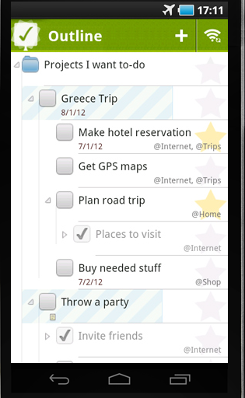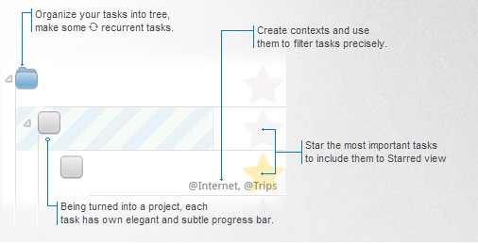

Outline tab

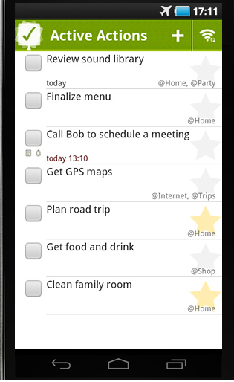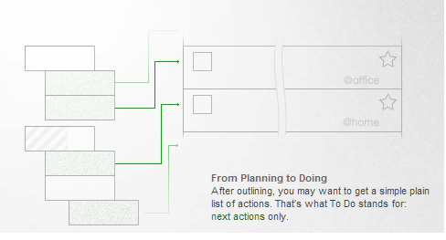

To do tab

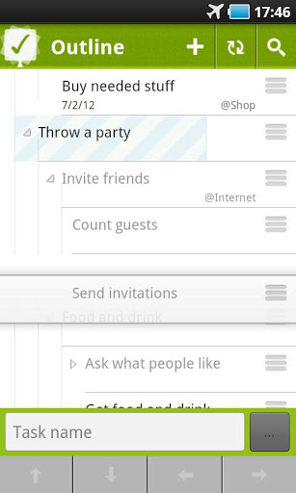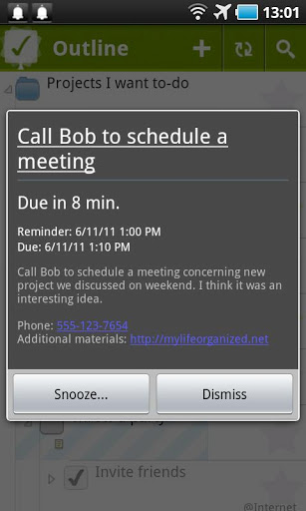

Main features

* Create tasks and any number of subtasks  
  - Assign contexts or star the tasks
* Combine tasks into project
* Filter tasks by contexts
* Add tasks to Inbox quickly
* Filter tasks by your current location

Advantages features

* Complete actions in a specific order
* Create recurrent tasks
* Set dependencies
* View tasks in different views including Next Actions, By Contexts etc.
* Zoom to a specific branch of task
* Location based alerts for active tasks
* Implement any task management methodology including Getting Things Done® (GTD®) and Autofocus or adopt to your own system.

Disadvantages features

* Do not support network data sharing
* Import, export form does not support XLS files.
* Configuration Helping/Supporting only in Windows XP and Vista

2 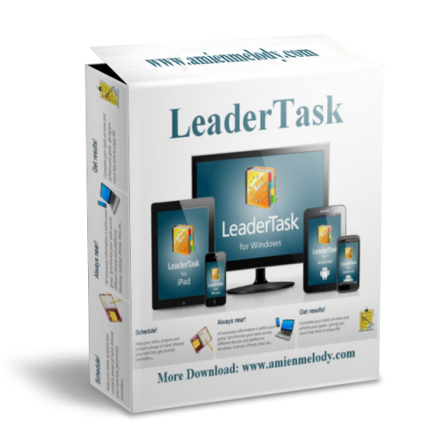 for Android

Producer: Almeza Company

Android system : 1.6 and up

Price : Free

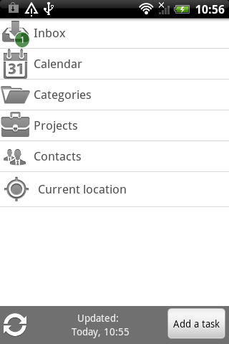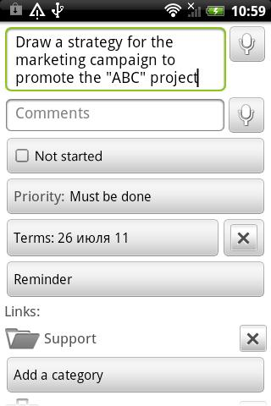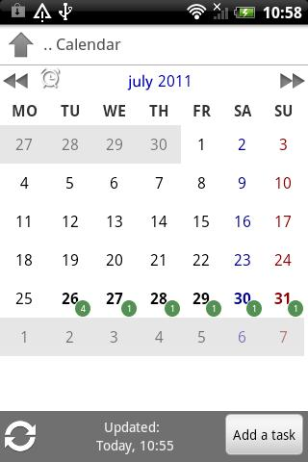

Interface New task Task in calendar

**Main Features:**

* Dictation tasks.
* Binding tasks with the GPS location!
* The tree organization of tasks.
* Calendar tasks.
* The grouping of project / category.
* Filtering tasks
* Reminders for time and GPS location!
* Sort by priority
* Search
* Widgets on your desktop

**Advantage features**

* Synchronize with your PC
* can bind current place in the category / project
* can show current location on map

**Disadvantage features**

* Do not support network data sharing
* Interface is not nice

**Moogly To Do List Widget Pro**

Producer : Fahrbot Mobile

Price : 1,99$

Android system :Android 2.1 and up

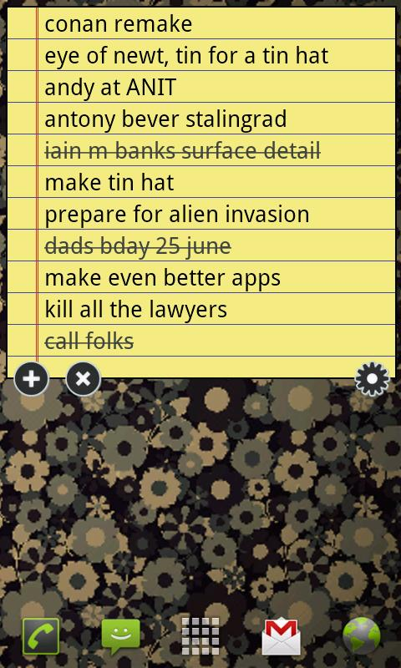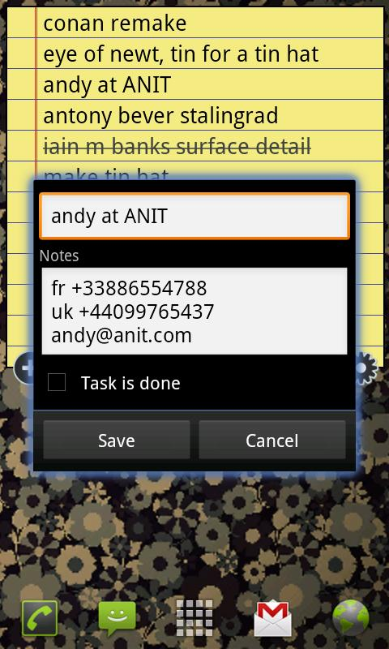

Edit task

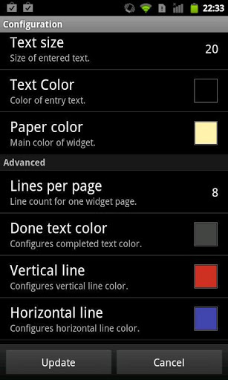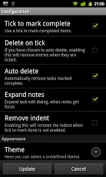

Configuration

Features:

* Multiple independent widgets
* Scrollable widgets on supported launchers
* Right-to-left support
* Predefined themes or total customization
* Custom image backgrounds

**Advantage features**

* Powerful task editing
* Quick, dialog based entry

**Disavantages features**

* Display too simple, too little information
* Does not expedient in big plan or high accuracy plan

Yata to do list

Producer: MiglySoft

Price: Free

Android system : 2.1 and up

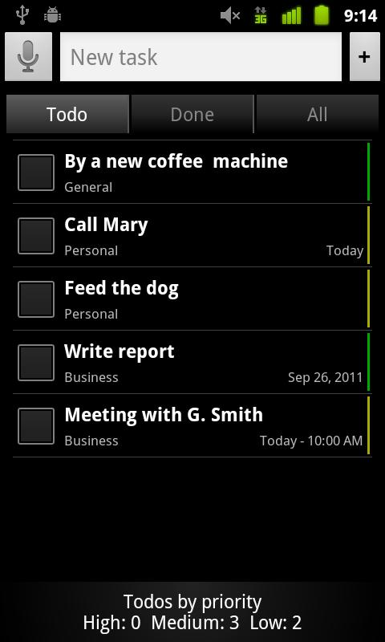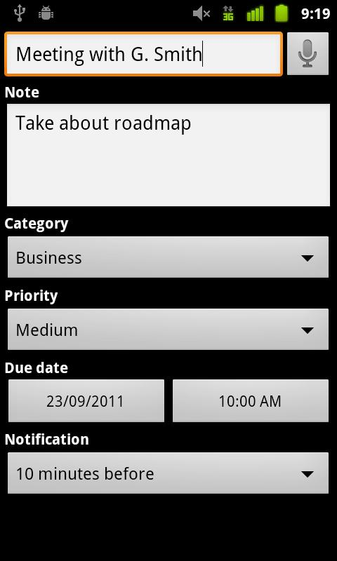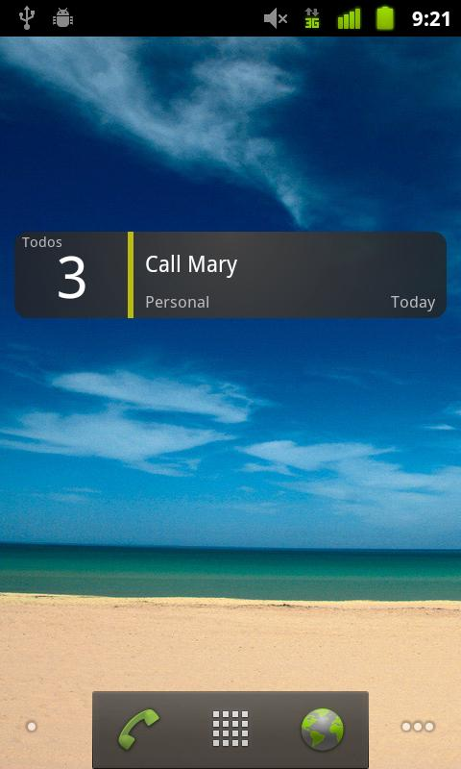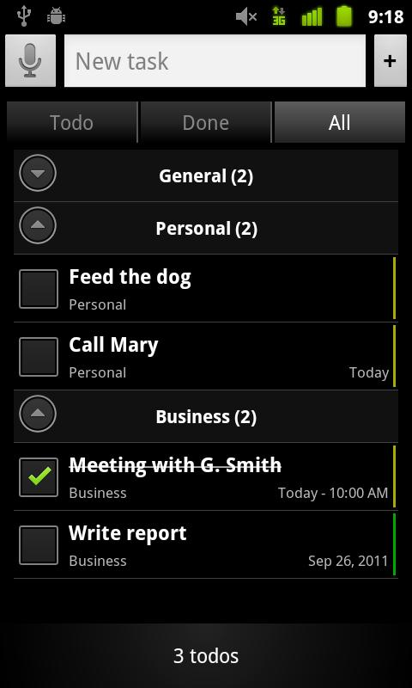

**Features**

* Edit tasks details: notes, date, etc..
* Categories: group and sort tasks by categories
* Priority: group and sort tasks by priorities
* Due date: group and sort tasks by date
* Notifications: setup notifications for tasks
* Send task list by email

**Advantage features**

* Google Tasks synchronization
* Widget for home screen
* Can add new tasks with voice recognition

**Disavantage features**

* Ram usage
* Back up option does not support

QuickTodo list

Producer : Jetpad org

Price: 0.85$

Android system :Android 1.6 and up

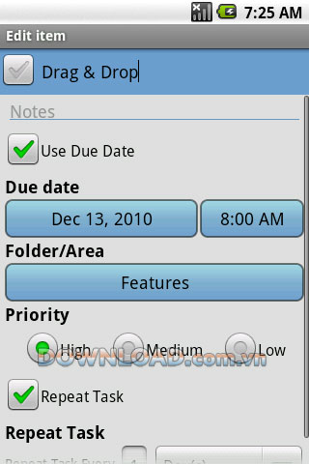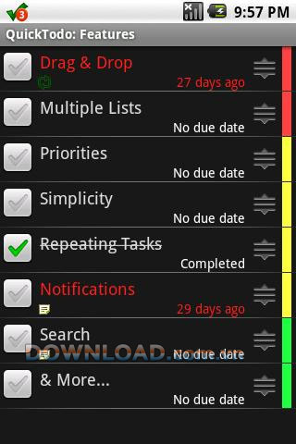

Features:

* Repeating Tasks
* Priorities
* Multiple Lists
* Drag and Drop
* Notifications
* Search

**Advantage Features**

* Overdue tasks appear in the notification bar.
* Drag and Drop

**Disavantage Features**